|  |  |
| --- | --- |
| J64 Build Guide | Abstract  A Raspberry-Pi based RetroPie machine that is DIY designed for MAME and S/NES.  Miles Punch |

J64 – Build Guide

This document (PDF)

3D Models (STL)

Entire Project

# Preface

So, you want to build the J64! It will serve you with good fun, and many hours of assembly, programming, and gaming. It is a Raspberry Pi based game console, designed for RetroPie and EmulationStation, enclosed in a 3D printed box. In this project, you will be faced with many common maker tools, such as Raspberry Pi’s, Soldering, 3D Printing, and Coding. Careful, as this may lead to a career in engineering!

# Tools Required

Many tools will either be required, or highly recommended for the assembly for the J64. They are listed below, as well as their source from Jaycar.

|  |  |
| --- | --- |
| Set of Small Screwdrivers | TD2182 |
| Basic Soldering Iron | TS1470 |
| Pliers/Crimp/Cutter | TH1986 |

# Bill of Materials

Many parts will also be required for construction of the J64. Some are integral parts that MUST be one-for-one, and are designed exactly for the product. The other are parts that can be swapped, or changed, or don’t have to be from Jaycar, such as screws and bolts. Replacement or alteration of the parts listed may result in damage to parts or equipment, or non-completion of the project.

## Parts Required

|  |  |  |
| --- | --- | --- |
| Part | Jaycar CAT# | Quantity Needed |
| Round Arcade Switch (Blue) | SP0666 | 3 |
| Round Arcade Switch (White) | SP0669 | 3 |
| Arcade Joystick | SM1052 | 1 |
| Small Normally Open Switch | SP0656 | 2 |
| USB Joystick Interface | XC9046 | 1 |
| M3 x 10mm Spacers | HP0900 | 2 |
| M3 x 10mm Screws | HP0403 | 2 |
| M4 Nylon Washer | HP0166 | 4 |
| M4 x 15mm Screws | HP0453 | 4 |
| M4 Nuts | HP0462 | 4 |
| Rubber Sticky Feet | HP0825 | 4 |
| Raspberry Pi 4B 4GB | XC9100 | 1 |
| Pi 4 Case | XC9110 | 1 |
| 16GB SD Card | XC9030 | 1 |
| 5V 3A USB-C PSU | XC9122 | 1 |

# 3D Print

The model for the J64 was done in Fusion 360 and sliced in Creality Print. All files (Fusion 360, STL) can be found in the “3D Models” directory of the GitHub page (QR Code at top of page).

The 3D Print for this project was originally done on an Ender 3 V3 KE and finished in just under 4 hours for the body, and 2 hours for the base. It used roughly 1/4 of a 600g roll and didn’t require supports. It did print with a brim, and this was removed with a sharp knife.



CAUTION: when using a knife, never hold the blade towards yourself, and exercise precaution when trimming the brim off a 3D print

# Button Layout

The button layout mimics the MAME button layout, and thus will work best with MAME ROMS and S/NES. This will be discussed later, when choosing games.



Y

X

L

B

A

R

JOYSTICK

COIN

START

# Pi Required

RetroPie is supported on every version of Raspberry Pi, including:

* Pi Zero
* Pi One
* Pi Two
* Pi Zero 2W
* Pi Four
* Pi Four Hundred

To select the right Pi and Pi Case, consult the manuals of each Pi. Every Pi will run most ROMs with very decent speeds and FPS’s. This project is very much geared towards a hobbyist with a Pi at home doing very little. Use any Pi to make this project work.

Other PC’s can be used to run the RetroPie machine, such as a laptop, both Linux, Mac, and Windows Machines, as well as RockPi and ODroid. Proceed at your own caution of your use of these.

# Assembly

## Buttons

Remove the body of the controller from the print bed. Use care to lift it minimizing damage to both the print bed and the object.

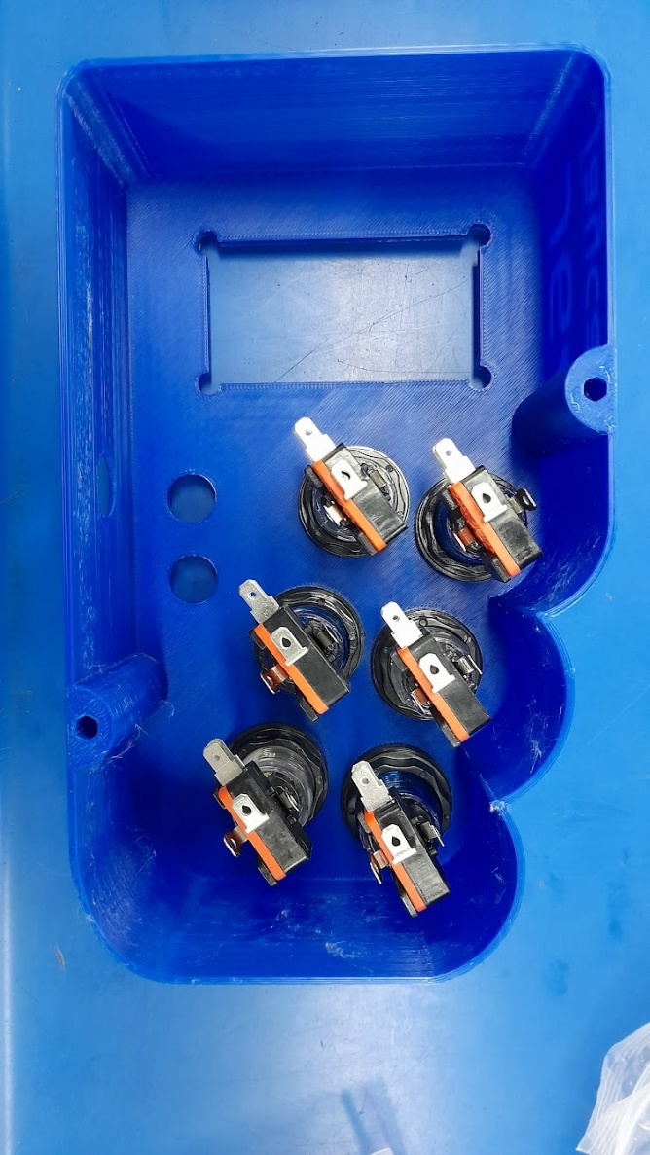

Take the six arcade-style switches, and put the button face through the front of the controller body. Secure them by putting the plastic nuts and washers on, from the other side. Make sure they’re not too tight.

Construct the six switch/light assemblies, by pushing the LED wedge into the socket on the black mount piece, and clipping the switch into the mount piece, paying attention to the dots on the switch, and the holes in the mount piece. Make sure the orange clicky notch on the switch faces towards the LED.

Screw the switch/light assemblies into the switches by means of an eighth turn into the switch clockwise. Note the notches on the lip of the button face to line up the entryway.

Take the four M4 bolts, and four of the nylon spacers, and thread the spacer onto the bolt.

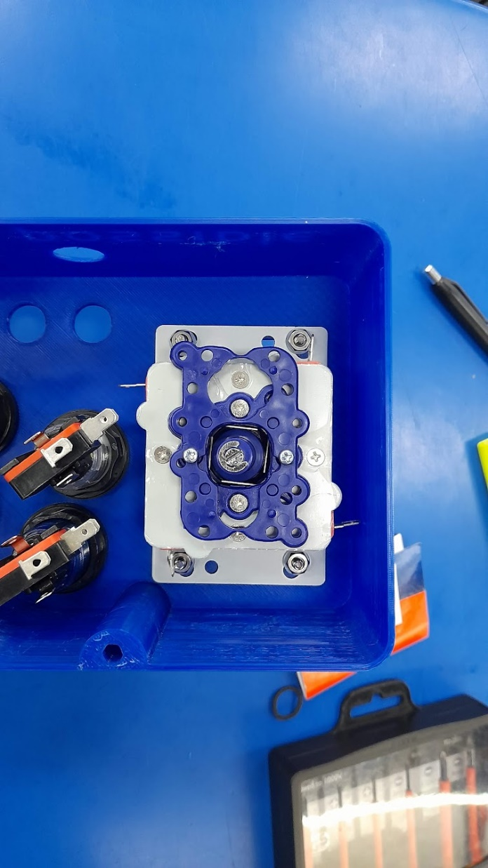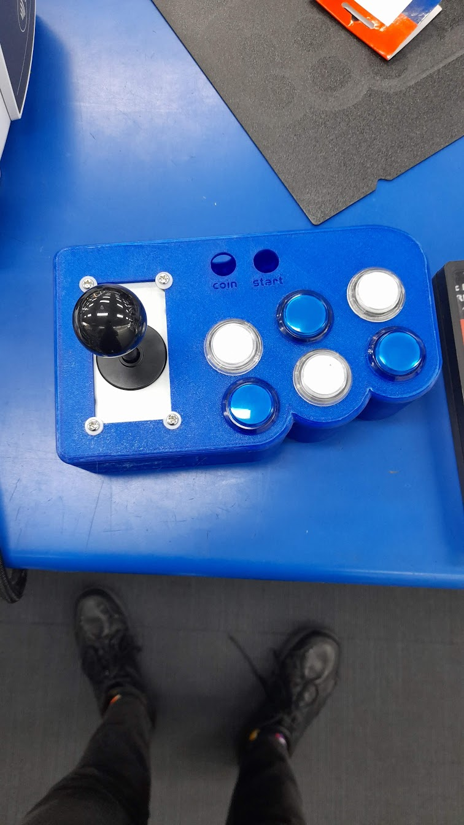Pass the screws with spacers (screw end outside) through the holes on the body where the joystick will sit, and insert the joystick, stick upwards, into the hole. It should line up evenly with the holes. Take the M4 bolts and fasten them up on the underside of the housing.

Pass the joystick’s cover plate onto the stick, and screw the joystick’s ball on top.

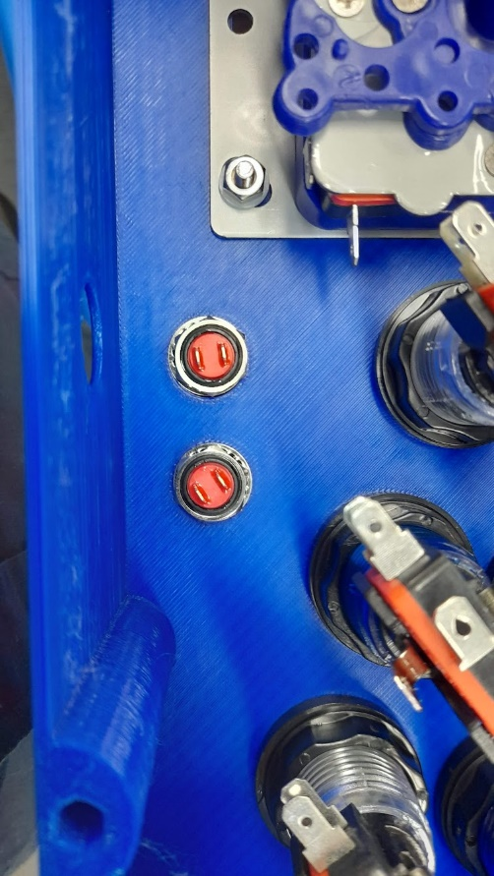Take the black micro buttons, and unscrew the washer and nut from the base.

Pass them through the case, button side up, and tighten the washer and nut back on from the reverse end.

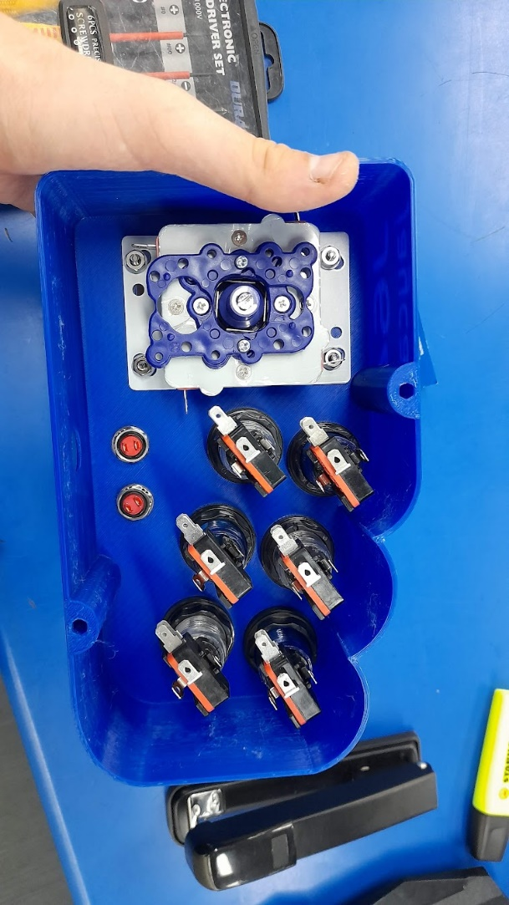Installation of the buttons and joystick is now complete.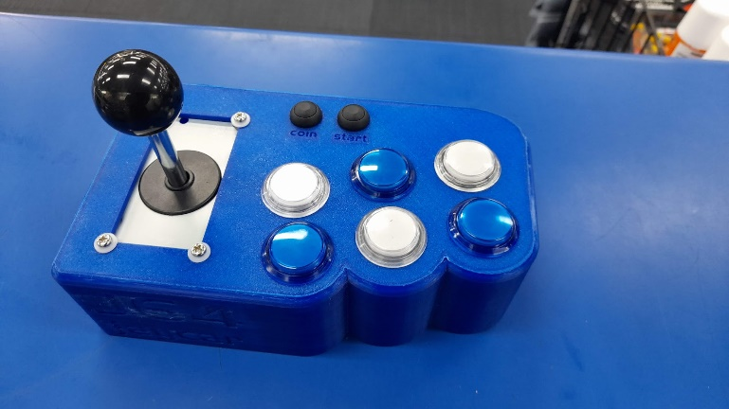 The finished product is pictured below.

## Wiring

Attach the crimps to the top and second-top spade terminal of each button, and the start and coin button. Then, connect these to any of the bottom row spaces on the controller board.

Via soldering, connect the joystick switches to the 5V rail (red socket). This can also be done with piggyback crimp lugs (PT4810), however it is up to you to connect these.

The joystick wires into a larger JST connecter on the bottom of the controller board, which can be cut and recrimped to connect the joystick. Watch the polarity and pinout to correctly wire it. VSS (+5V) should connect to one leg of the switch, and the other 4 should connect to the separate legs of the switches on the joystick.

Order into the bottom row is not important. The mapping phase will organize these into the software stage.

Plug the USB cable into the board, and pass it out the hole.

## Closing it up

Put the M3 spacer in the hex hole and use a soldering iron to close the edges of the hole and hold the spacer in place. You can use the iron to push the edge plastic over the lip of the spacer.

CAUTION: when using a soldering iron, always pay attention to where it is, and when it’s on. Never leave the iron unattended when powered.

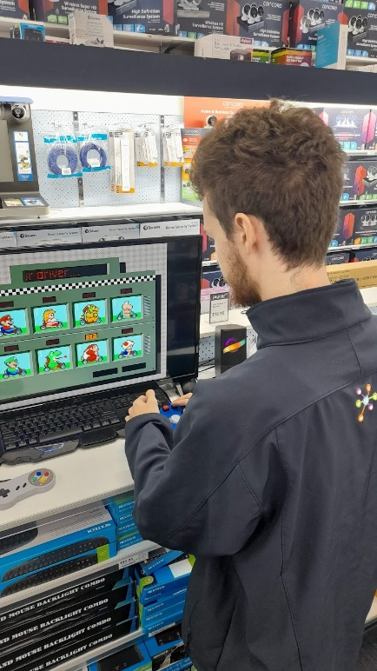Place the M3 screw through a nylon spacer, through the baseplate and screw it into the body once all cables are passed through the hole. Unstick the rubber feet, and stick them evenly on the controller. This concludes the construction of the controller. Plug it in, via USB to the Raspberry Pi.

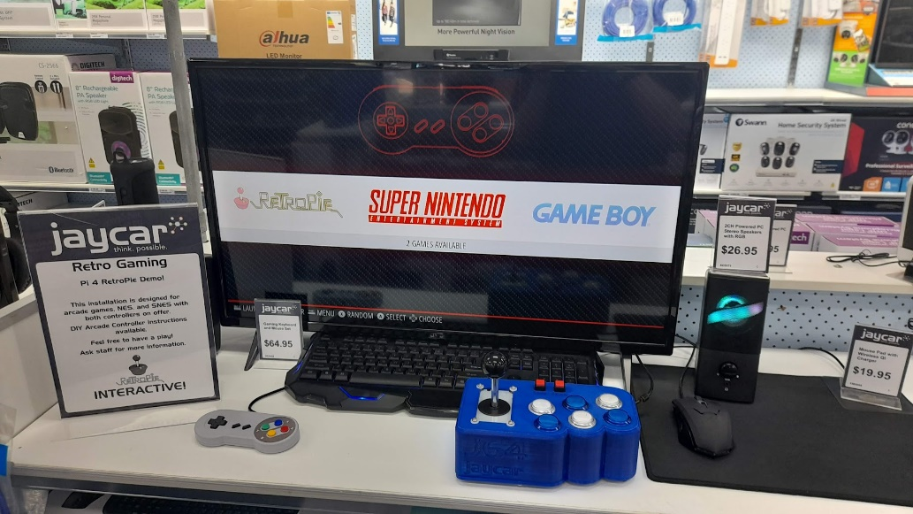

Enthralling J64 action!

Original J64 Controller and Setup at Maitland Jaycar

# Installation

To get an installation of RetroPie, head to the RetroPie Downloads page. A QR Code is provided on the right.

RetroPie Downloads

### A screenshot of a computer Description automatically generatedDo you have a Pi 2/3?

Click on the link circled in blue, to download the Raspberry Pi 2/3 package. This will download a .img file that can later be used to install RetroPie on the Pi.

### Do you have a Pi 4/400?



BalenaEtcher

Click on the link circled in green, to download the Raspberry Pi 4/400 package. This will download a .img file that can later be used to install RetroPie on the Pi.

To write the installer to the SD card, you will need a etching program, such as Balena Etcher.

Once downloaded, unzip and run to reveal the interface.

### Step 1: Load File

Press *Flash From File* and navigate to the file just downloaded. Press *Open*, which will take you back to the Etcher interface.

### A screenshot of a computer Description automatically generatedStep 2: Select Target

The next installation step is to press *Select Target* and tick the box of the SD card. It is important you tick only the box that is the SD card you would like to write it to.



CAUTION: when formatting drives, be careful of other drives on the computer. Data can be lost by ticking the wrong box.

### Step 3: Flash!

Press flash!

This process may take up to 20 minutes, so go and boil the kettle while you wait, maybe have a biscuit or two.

### A green circuit board with a red circle Description automatically generatedStep 4: Boot on the Pi

Remove your SD card from the computer, and put it in the Raspberry Pi. Apply power to the Pi via the MicroUSB port, plug in a monitor via HDMI, and watch as RetroPie installs. The first time booting will take longer as RetroPie installs. You may need to follow the installation with a keyboard to enter some values.

# Controller Setup & Compatible Controllers

## J64 Controller

MAME controllers and RetroPie go together like butter and toast, but need a little work to work optimally for all games. On RetroPie’s first boot into EmulationStation, it will prompt the user to configure a controller.

Hold down any button on the J64 to register the gamepad to RetroPie. It will then ask you for a series of “mappings” to tie buttons to controls, however, there aren’t enough buttons for each game control. Below is a table of what to press for each one.

|  |  |
| --- | --- |
| Screen Name | What to press |
| D-PAD UP | Joystick UP |
| D-PAD DOWN | Joystick DOWN |
| D-PAD LEFT | Joystick LEFT |
| D-PAD RIGHT | Joystick Right |
| START | Start Button (Right Black Mini Switch) |
| SELECT | Coin Button (Left Black Mini Switch) |
| BUTTON A/EAST | Bottom Middle Arcade Switch |
| BUTTON B/SOUTH | Bottom Left Arcade Switch |
| BUTTON X/NORTH | Top Middle Arcade Switch |
| BUTTON Y/WEST | Top Left Arcade Switch |
| LEFT SHOULDER | Top Right Arcade Switch |
| RIGHT SHOULDER | Bottom Right Arcade Switch |
| LEFT TRIGGER | [HOLD DOWN ANY ARCADE SWITCH] |
| RIGHT TRIGGER | [HOLD DOWN ANY ARCADE SWITCH] |
| LEFT THUMB | [HOLD DOWN ANY ARCADE SWITCH] |
| RIGHT THUMB | [HOLD DOWN ANY ARCADE SWITCH] |
| LEFT ANALOG UP | [HOLD DOWN ANY ARCADE SWITCH] |
| LEFT ANALOG DOWN | [HOLD DOWN ANY ARCADE SWITCH] |
| LEFT ANALOG LEFT | [HOLD DOWN ANY ARCADE SWITCH] |
| LEFT ANALOG RIGHT | [HOLD DOWN ANY ARCADE SWITCH] |
| HOTKEY ENABLE | Coin Button (Left Black Mini Switch) |

Hotkey Enable sets the two keys that you press to exit a game, which in our case is the two mini black switches. When both are depressed, the game will exit.

## Other Controllers

For more information on configuring other controllers, follow the QR code on the right to the official docs page on the recommended mapping.

Controller Config

Supported controllers include:

SNES Controllers, Xbox 360/One/X/S, Sony Dualshock 3/4/5, Logitech F310, WiiMote, N64, Bluetooth Controllers, 8BitDo, WiiUPro, and Keyboard.

# USB ROM Drive

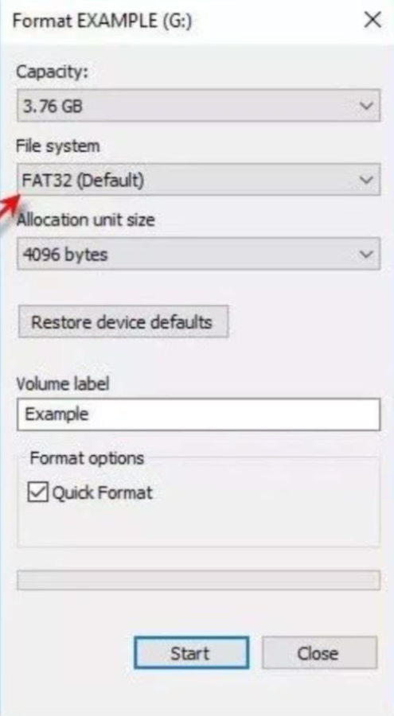Format a drive to FAT32, as it’s the most compatible to devices, such as the Pi. Create folder on the drive called “retropie-mount”, plug it into the Pi. Let it run for about 3 minutes, then unplug it and plug it into a computer. This will create more subfolders in the folder “retropie-mount”, such as “roms”. Deposit the ROMs to the folder of the system they’re from, such as the folder called “n64” for Nintendo 64 ROMs.

## Controller Compatibility

The best games/systems for the J64 were:

* NES (Tetris, Street Fighter 3)
* SNES (Super Mario Kart, Strike Gunner)
* Game Boy (Street Fighter II, Pokemon Red)

# Finding Games

The J64, while built around MAME ROMS, will play any game supported by RetroPie. A list of all available emulators built into RetroPie can be found at the QR code to the right.

Several games are available that can either be bought from the developer or are open-source, and thus do not have a legal implication of ownership. A source for copyright-free MAME ROMs can be found on the right.

Supported Emulators

# Legal

All designs, code, and intellectual property remain the property of the author. Fair use is granted for non-commercial purposes, however modifications to designs or code are allowed. Jaycar nor the author endorse piracy or unauthorized downloading of games or files beyond the developer’s control, such as using websites intended for distribution of pirated games. ALL DEMONSTRATION UNITS OR DISPLAYS MUST HAVE THIS DOCUMENT AVAILABLE WITHIN THEIR VICINITY.

Free MAME ROMs

## Author

Miles Punch – Jaycar Maitland

For questions, more information, or revisions of information, please contact:  
miles@punchav.com